ANKARA UNIVERSITY
ENGINEERING FACULTY
DEPARTMENT OF COMPUTER ENGINEERING


COM 492 PROJECT REPORT

A Neural Expert System Based Dental Trauma Diagnosis Application for Wearable Devices

Seçkin ŞEN 14290117
Oğuz FARSAK 14290096

Gazi Erkan BOSTANCI

10.06.2019

ABSTRACT

Dental traumas are frequently observed challenging medical situations that the dentists need to handle. This requires a quickly made correct diagnosis and treatment to prevent further complications. Follow up procedures also need to be properly planned for the treatment to be completed successfully. The main goal of this study is to develop a system that facilitates the diagnosis and treatment process for the general dentists and dental students by providing an easy method of accessing a standard guideline in dental traumatology. But this system has a big advantage from another expert systems. By using neural network this system can create its own rule with examining previous diagnoses. Thus, the system can find new correlations never known before between symptoms.

This study presents an expert system which takes the International Dental Trauma Association's Dental Trauma Guidelines as the rule-base and performs data-driven forward chaining inference approach to decide on the type of the trauma. Once the diagnosis is completed, the dentist can generate reports of the complete process and plan the follow up procedures in detail. Patient information can also be stored using this system which can later be associated with a hospital management system. The developed application can run on both smart glasses and mobile devices such as smartphones and tablet PCs.
In this study, a wearable diagnosis system was developed by employing an expert system based on the rules from the current gold standard, IADT, for the management of traumatic dental injuries. The system is capable of reasoning using a forward-chaining mechanism and is able to diagnose the injury type, from simple cases to the most complicated ones as well as reporting the decision-making process along with patient data.

This is the first wearable diagnosis system in dentistry for diagnosis of dental traumatic injuries along with multiple other features. This device is thought to be helpful for specialist dentists, preterm dentists and even dental students for the diagnosis, treatment and follow-up sessions of dental trauma.

TABLE OF CONTENT
ABSTRACT ii
TABLE OF CONTENT iii
ACRONYMS AND ABBREVIATIONS iv
LIST OF FIGURES v
LIST OF TABLES vi
1. INTRODUCTION 1
2. MOTIVATION 3
3. MATERIALS AND METHODS 6
3.1. Node JS 6
3.1.1. Express 6
3.1.2. Node-rules 6
3.1.3. Mysql 6
3.1.4. Nodemailer 6
3.1.5. Asyn 6
3.1.6. Fs 6
3.1.7. ChildProcess 6
3.2. Android Studio 6
3.3. MySQL 6
3.4. Weka 7
4. RESULTS AND DISCUSSION 10
5. References 12
6. APPENDICES 16
6.1. APPENDIX 1 (FIGURES) 16
6.2. APPENDIX 2 (TABLES) 19

ACRONYMS AND ABBREVIATIONS

ANN Artificial Neural Network
CNN Convolutional Neural Network
IADT International Association of Dental Traumatology
KBANN Knowledge Based Artificial Neural Network
MAE Mean Absolute Error
RMSE Root Mean Squared Error
SLP Single Layer Perceptron

LIST OF FIGURES
Figure 1. System Architec 16
Figure 2. Forward-Chaining Method 17
Figure 3. Architecture of KBANN 18
Figure 4. Creating New Rule Sample 18
Figure 5. Used Devices 19

LIST OF TABLES
Table 1. The KBANN Learning Algorithm 19
Table 2. Performance Comparision Among Some Weka Algorithms in Cross-Validation 10 Folds Test 19
Table 3. Comparision With Tooth SOS Application 19

INTRODUCTION

Trauma in the mouth area is fairly common and involves 5% of all injuries (1). In pre-school children, face injuries that do not involve the head and mouth area constitute up to 40% of all body injuries (2). Dental trauma is most common in younger people, accounting for 18% of injuries to the body (1, 2). Child health is especially affected by such traumas since these traumas may have physical, esthetical and psychologic consequences (3).
There are many studies around the world evaluating dental trauma related to the management and recognition of different types of dento-alveolar injury. Most of them showed that dentists' knowledge was insufficient and could not effectively manage such cases. Some of the results revealed that there was an unequal distribution of information among doctors regarding emergency management of dental trauma (4-11). There are also studies suggesting that information deficiencies are determined in dental trauma cases of dentistry students and that their knowledge should be increased in this regard (12,13).
In a study a closed-ended questionnaire was sent to general dental practitioners and community dental officers in UK, to evaluate dentists' knowledge of the emergency treatment of traumatic injuries to young permanent incisors, and to investigate barriers to treatment and results showed that dentists' knowledge of the emergency treatment of dento-alveolar trauma in children was inadequate (9). As a result of an examination of the questionnaire which aimed to evaluate the general dentist's knowledge about the management of primary teeth traumatic injuries; 49% of dentists answered accurately regarding avulsed primary teeth, 36% of dentists answered appropriately regarding crown and root fractures, and 55% of dentists gave appropriate answers regarding luxation injuries (14). In another study to evaluate the diagnostic skills and treatment acumen of 55 general dentists related to dental injuries, and other conditions in children. Two questions were included to evaluate treatment acumen of general dentists regarding dental trauma in children. Correct alternative of the treatment was given by 53% dentists in case of extrusive subluxation and by 49% dentists in case of avulsion of
mature tooth (15).
Early intervention in the management of dental trauma can significantly alter the results of treatment; all clinicians should be sufficiently trained to manage traumatic events effectively (16). Time is reported to be the most critical factor in the treatment of some dental trauma types (17). An example can be given here for avulsion cases as the shorter the reimplantation time, the lower the likelihood of observing later complications (18).
IADT has prepared detailed guidelines for making quick and accurate diagnosis (19). These guidelines are in form of a decision tree which the dentists can follow to reach a specific type of trauma. Once the diagnosis is made, the treatment plan can also be created according the guidelines. Following the treatment, the guidelines also offer follow-up procedures and methods for handling the complications that may occur. The use of such a detailed guideline is important to perform standardization in the diagnosis and treatment procedures.
An expert system offers several advantages over human experts. First advantage is consistency which can be described as the ability to come up with the same answers each time the same questions are provided. Memory is another advantage since computer systems are capable of storing and processing large amounts of data. Finally, the decision-making process in expert systems is logical and objective, purely based on rules defined on the system (17). These properties of expert systems make them attractive in challenging decision-making processes such the diagnosis of dental traumas.

The main objective of this paper is to present an expert system based dental trauma diagnosis system developed using the guidelines mentioned above. The developed system can be used on both mobile and wearable devices such as smart glasses so that they can be used seamlessly at the time of diagnosis without affecting the normal interaction of the dentist with the patient. The system uses forward-chaining to reach a conclusion based on the findings by automatically inferring outcomes based on the IADT guideline tree. The complete guidelines were included in the system where a dentist can select the clinical and radiologic findings from the menus available.
This system is not intended to replace the clinical diagnosis; however, is intended to be used as a support tool for ensuring that the IADT is employed in the diagnosis in a more user-friendly fashion than a poster where the guideline is presented. This is due to the fact that people are familiar with mobile devices in today’s world and can easily adopt to new software tools. Another advantage of the system is that the system can process the symptom data to come up with the correct diagnosis. This will support general dentists and dental students.

MOTIVATION

This section presents a summary of previous studies in the fields of dental trauma, expert systems and wearable technologies.
The literature on dental trauma reveals that tooth injuries are the most common of the mouth area injuries and are followed by soft tissue injuries. Due to the frequency, emergencies are a challenge for clinicians all over the world (3). It can cause much pain and distress to both parents and children. Many reports indicated that dental trauma accounts for a fairly high percentage of cases presenting at hospital emergency departments (20,21).
Today, a major threat for the health of children from injuries that occur in childhood and dental injuries represent serious problems affecting children physically, aesthetically, psychologically and traumatic injuries to the primary teeth can affect the development and eruption of the permanent teeth (3,22). The treatment of traumatic dental injuries is a complex task, accurate diagnosis and treatment can sometimes be very difficult to achieve in the process of diagnosis (23).
The examination and treatment of a child admitted to the health center with dental trauma is often difficult due to lack of cooperation and fear (24). Therefore, it is of utmost importance that the diagnosis be made as soon as possible in case of dental trauma where time is very important in the beginning of treatment. Diagnostic goggles that are produced for this purpose are very useful for the application of the most effective and correct treatment to the patient who applied with dental trauma as soon as possible.
Dental trauma cases usually result in a treatment sequence that includes a wide range of dental professionals, including oral and maxillofacial surgeons, pediatric dentists, endodontists, orthodontists, prosthodontists and periodontists. Primary emergency care is usually provided by the oral and maxillofacial surgeon or pediatric dentist or a general dentist in hospital emergency services (19). It is extremely important that emergency intervention in the light of a proven course of treatment for dental trauma involving almost all specializations and the availability of access to this knowledge is of great importance.
Management of dental trauma in children can especially be a challenging problem in dental practices. Knowledge of current trauma guidelines is vital in effectively managing dental trauma so that favorable outcomes are achieved (25). A treatment guide for dental injuries in children should help decide on dentists and other health professionals. In addition, this guide should be reliable, easy to understand, and practical in order to ensure that the best possible care is delivered in the most efficient way (26).
IADT prepared and developed considering the 2012 treatment guide, and it is hoped that this diagnostic tool will help the clinician in the diagnosis, treatment and follow-up stages of dental trauma.
An expert is a person who has deep knowledge and strong practical experience. In other words, expert is well-versed in a specific topic. Expert systems are programs which aim to mimic what experts can do.
The literature reveals several successful studies using expert systems in both medical diagnosis and other decision support systems. In 1967, DENDRAL (27) was developed by to use spectrographic data in order to identify chemical structure of substances (27-29). Other expert systems followed this successful application. Some of them are MYCIN, CASNET (Causal Associational NETworks) (30), EXPERT (30), HELP (31), PUFF (Pulmonary Functional Data) (31), ONCOCIN (32), INTERNIST-I/CADUCEUS (33), QMR (Quick Medical Reference) (34), RECONSIDER (35), CLOT (coagulation problems) (36), HEAMED (psychopharmacology) (36), CADIAG-2/PANCREAS (pancreatic diseases) (37), MEDUSA (38).
MYCIN was the one of the oldest expert systems. It uses rule-based approach. It competed against human specialists and showed that it was a worthy opponent (39). As a result of success of MYCIN, new expert systems are developed. This research is good example to show the power of the rule-based systems.
A detailed comparison of various expert systems was given by Alder et al. where 19 expert systems developed for rheumatology were compared based on the number of correct diagnosis, sensitivity and specificity. The percentage of correct diagnosis ranged between 43.1% to 99.9% while sensitivity and specificity values ranged from 62% to 100% and from 88 to 98%, respectively (40). It is worth mentioning that validation of such systems is vital so that they can have a place in daily practice; however, it is clear that these systems have a great potential once the validation is performed adequately.
Nowadays, expert system applications are used in medical commonly. These applications can be
divided into categories as follows (41);
✓ Alerts and reminders: They are used to inform or warn changes in patient’s condition.
✓ Therapy critiquing and planning: These systems check the plans to see if there is an error.
✓ Prescribing decision support systems: Especially used to check drug-drug interactions, dosage errors and allergy.
✓ Information retrieval: They are generally used for searching. For instance, user gives
necessary information like what he needs, what symptom he has. After that, program searches on internet to diagnose.
✓ Image recognition and interpretation: These systems analyze clinical images like X Ray, angiogram, CT and MRI scans. These systems can detect some points which may be missed by doctors.
✓ Diagnostic assistance: Using evidences, system can diagnose. When the rules are generated well at the beginning, system can detect the illness better than doctor (28).

Rule-based expert systems are found to be most popular among other types since they offer natural knowledge representation, uniform structure, separation of knowledge from its processing and dealing with incomplete and uncertain knowledge. On the other hand, their disadvantages are reported to have opaque relations between the rules, inefficient search strategy and showing an inability to learn (29).

It is meaningless to expect a person to know or classify what it is that he has not seen before. You should be given some information about what is shown to the person before the person asks him / her to do such a thing, or a lot of related examples should be given (51). We cannot expect a system to correctly classify previously unidentified data, like a human. Critical features should be given to the system to classify and recognize class members. The system must know the rules specific to the data that it can extract from the given samples. The system uses these rules to determine whether an object belongs to a class. This is called ”domain theory”. Apart from giving the system the original inference rules to the system, you can provide the system with a lot of examples to make classification with telling them whether the samples belong to that class (51). These two methods can be defined as the opposite of each other. Only the structure where the information is given is defined as a hand-build classifier (51). Expert Systems are examples of this structure. Hand-build systems can’t learn anything. Structures where examples are given and no qualification information is defined as empirical learning. In the empirical learning structure, no information is given about why the data belong to that class. These two methods have their own problems. However, by combining these two methods, the problems of the methods can be relatively reduced by creating a hybrid structure. A new structure can be created by putting the hand-build classifier and a neural network together and giving examples to this network. These structures are called Hybrid Systems, and the KBANN is an example of a hybrid system. Briefly, hybrid systems accurately classify previously unseen samples using theoretical domain knowledge and a set of classified samples (52).
KBANNs, a hybrid system, consists of two structures that we have already mentioned. Symbolic learning and Empirical Learning (53). The symbolic learning part includes domain theory, initial knowledge, and rule sets, while the empirical learning part consists of neural network and sample sets. The KBANN learning algorithm is defined by Towell (51) as in Table 1.
KBANN uses knowledge-specific rules. Knowledge base may be not completed or incorrect. KBANN places the field information in the ANN. KBANN transforms these knowledge bases, ie rules into ANNs (54). The lack of the ability to explain why a trained ANN has given a particular decision makes it difficult to trust the solutions the network presents to problems in the real world (55). KBANN enables the development of ANN and can creates new ANNs.
KBANN is used in many areas. Although it is widely used in health and biology fields such as in molecular biology analysis and classification of DNA sequences (54), characterizing medical problems, diagnoses many critical diseases such as breast cancer and pulmonary embolism (53,54) and recognizing personalized emotion (55); it is also used in areas such as handwriting or voice recognition.
The word “wearable” is often used with technology (wearable technology) or devices (wearable devices). According to the definition by Tehrani (42,43), wearable devices are "electronic technologies or computers that are incorporated into items of clothing and accessories which can be worn comfortably on the body". Smart glasses are the first devices that come to mind when thinking of wearable technology and most well-known ones are Google Glass, Epson Moverio, Vuzix M100, Optivent Ora. These are not the only smart glasses on this emerging market. In general, these devices have a camera, monitor, speaker and Wi-Fi connectivity. Although they have common features, they have differences. Their price, control, display resolution, field of view (FoV) are some of their differences. In recent years, many studies have been conducted to develop wearable devices to be employed on a wide range of applications. For example, health monitoring, surgery, telemonitoring, health data access and medical education are used in the field of healthcare (44,45).

MATERIALS AND METHODS

Node JS
This platform written using JavaScript is used to build a server. One of its advantages is there is no need to waiting. Different from PHP, Node JS use single non-blocking thread for request. It provides Node JS to deal with lots of requests concurrently. Another advantage is built-in NPM support. NPM is a package manager for JavaScript. Thousands of modules are available in NPM and they can use in Node JS easily. In addition, some modules are used for other purposes.

Express
Express is a Node.js web application framework. It is one of the most popular packages in NPM. It is used for routing and using middleware.

Node-rules
Node-rules is a forward-chaining engine. It also allows us to control the engine even it is running. For example, rules can be altered, added, deleted or their properties can be changed such as their priorities, IF-ELSE parts. Rules can be imported and exported.

Mysql
It is used to connect MySQL database and retrieve query results. Working with MySQL in Node JS is simple. In addition, there are pretty many sources available.

Nodemailer
It is used to send e-mail. It makes easy to send e-mail.

Asyn
Nested mysql connection may need. It is used to iterate query results and make process with each of result rows.

Fs
Fs module allows you to work with the file system on the running device. It is used to create and save PDF files.

ChildProcess
This module is used to run executable jar file in the server. Created ANN is run thanks to this module.

Android Studio
It is official tool of Android. It has a lot of advantages to use for developin Android applications such as complete support and simple integration. Including SQLite, number of built-in libraries are used. It is used to develop application which can be used on phones, tablet PC and smart glasses.

MySQL
It is fast, portable, secure, reusable and transparent database management system. Using mysql module, database is connected to the server.

Weka
That framework is used to create ANN to learn new rules. It was preferenced because of easebility of usable. ANN is created by using Java. After that, the program is exported as executable jar file.

The developed system is elaborated in this section by giving details on how system architecture is designed, the expert system is employed, data persistence is achieved, and user interface is developed. Helping dentists to diagnose and treat dental traumas is main goal of this project. It is also aimed to prevent patients suffer because of misdiagnosis. Doctors will use the program via their device running Android Operating System (Tablet PCs, smart phones and smart glasses). In this program, dentists can register new patients, change or deleted stored records. Altering records do not only involve making changes on personal information but also the medical examination reports. Patient’s symptoms are sent to a server for the diagnosis. When the server decides on the dental condition, this is sent to the dentist’s device. According to result, a report will be generated automatically, which can be converted to PDF file. This process is shown in Figure 1.
The system is developed according to the client/server architecture. Server waits for requests from clients and responds to these requests. The device used by the dentist is regarded as the client side. The inference mechanism for the expert system is on the server side. The information entered by the dentist is sent to the server and here it is compared against the rules in the rule-base. Forward-chaining is an inference method used for inference in a data-driven manner and is used here to infer the type of the dental trauma based on the symptoms.
Server side is created using Node JS. To make building the server easier, express module was used. Rule generation and forward-chaining was made by using node-rules module. The expert system is implemented on the server side and this will be used by the clients running the client part of the application.
This system was aimed for the dental trauma case; however, the inference mechanism can be used for different applications such as the diagnosis of oral pathology. An example flow of the inference mechanism is described using the following simple scenario. Symptoms observed by the dentist are as follows: Traumatized tooth is a permanent tooth. This tooth has mobility and displacement. Several teeth are moving together with alveolar bone. Using these symptoms, the inference mechanism tries to reach conclusive diagnosis. For this purpose, first the antecedent parts of the rules are checked according to the symptoms, next the matching rules are executed. Here the order of execution is important since the results of one cycle will affect the input of the next cycle. The diagnosis is completed once all the available information is used along with the rules. This process is depicted in Figure 2. Expert systems make use of priorities and time-stamps to prevent collisions where different antecedents may result in conflicting consequences; however, the system developed here has separate symptom paths since it is based on the IADT guideline.
The server compares the symptoms (facts) with rules. After comparison, if any illness is diagnosed, all information (for now name, treatment, follow-up procedures, favorable and unfavorable outcomes of the trauma) is fetched from the database and server sends this information back to the dentist's device. This database is created using MySQL. Patient symptoms and the result which is created using these symptoms are sent as JSON objects over HTTP Post queries.
This project contains two databases. First one is for end user’s database. It is unique for all devices. Doctor keeps the personal information about his or her patients, their reports. Thanks to SQLite, recorded reports and patient information are kept locally on the device.
Second is the system database stored on the server. Expert system may require a large amount of memory for both the storage of the rule-based system and the inference mechanism. Performing such an operation on the client-side may be inefficient, this is the main reason why the two-tiered approach is followed here.
The user interface is designed to be user-friendly and easy to use. A toolbar is placed on the top along with a green button to enter and send the symptoms. There are three slide pages below this toolbar. First slide is about patients. Patients’ personal information is simulated in this slide. Registered patients’ names are listed on the right side of the slide. When one of these names are tapped, personal information of the selected patient is shown on the left part of the slide.
The user interface offers searching and adding features above the list. When the search button is used, the button converts to an edit text and results which are matched with searched text, are listed on the registered patient list. Add button is used to register a new patient. When this button is used, a new page is opened. The dentist fills the editable fields with the new patient’s personal data in this page. After that, the patient data is registered on the device's database. Patient data can be removed by holding on a patient's name using the touch screen. After few seconds, a pop-up message opens to receive confirmation from the user. If the user confirms, selected entry is deleted from the SQLite database.
Second slide is about dentist profile. In this page, the dentist must add information like email address. This information is not essential but improves the usability. For example, server sends the reports to the dentist’s email address.
Third slide is about reports. This part depends on the first slide since here the reports shown belong to the patient selected on the first slide. This view takes report data for the active patient such as report date, diagnosis, diagnosis path, treatment, follow-up procedures, favorable outcome and unfavorable outcome of the treatment. CT images related to the trauma can also be appended to the report created by the system. Once the report is created, it can be exported as a PDF file to the dentist's email address. Reports can also be queried using a search facility.
The green plus sign button is used to input symptom data from the dentist for diagnosis criteria such as clinical findings and existence and type of the mobility.
Test instance is sent to the server. Using all rules which are known at the beginning, fully connected ANN is trained. All nodes in input layer demonstrates situation of symptoms. All symptoms can be in three position. If the symptom exists, it is expressed as 1. If it does not exist, it is expressed as -1. If the presence or absence is not known precisely, it is expressed as 0 (unknown situation). In input layer, all symptom has three nodes for these three positions. Output layer nodes represent diseases. Network makes classification to the test instance after training. Classifying process If the network classifies correctly, it sorts all input layer nodes starting with the most important. That importance is determined by the absolute value of weight of the node. The most important symptom is written to the rule. The weights of the symptoms written the rule is summed if that node does not symbolize unknown situation. We can call that sum as KNOWN. This process is repeated until the sum of the weights of the symptoms written in the rule is greater than the sum of the absolute values of weights of the remaining symptoms (KNOWN > UNKNOWN). Mathematical expression shown in Formula 1. The goal is to create the rule using the least number of symptoms.
(1)
Where i ∈ KNOWN, j ∉ KNOWN and n is the number of neuron inputs in Formula 1.
Symptoms which are summed (KNOWN) composes IF PART of the new rule. Value of class attribute which is disease's name also, is going to be ELSE PART of the new rule.
ANN is created by using Multilayer Perceptron algorithm with zero hidden layer inside Weka framework of Java.The structure of KBANN is like SLP as seen in Figure 3. The reason for no using multilayer structure is lack of pre-information about problem domain. In order to build multi-layer structure, input (symptoms) nodes must be associated with hidden layer nodes very carefully. Because in the new structure the system will not be fully connected. All input nodes will not feed all next layer nodes. The same sitiation is valid for output layer (diseases) nodes. All hidden layer nodes will feed all nodes no more. The system can only be converted into a multilayer structure with the help of experts.
Table 2 gives a comparison of the performance of some classification algorithms within the Weka framework. Created ANN is exported as executable jar file. That file runs on the server. Training data and test data are in arff format.
If the user wants to use his or her own created rules, rules are sent with symptoms to the server. The server inferences the illness by using rules come from the user by using KBANN as explained previously. Creating new rule process is given as sequential diagram in Figure 4.

RESULTS AND DISCUSSION
Table 2 shows the performance comparison of the different algorithms for using classification of instances created according to the IADT guidelines. Multilayer Perceptron algorithm, which is used as seen, has made correct classification in %78.125 ratio in cross-validation 10 folds test. It proves that expert system which uses that algorithm in its knowledge base can learn.
A medical report can be converted to PDF file format and sent to the dentist's device. The report contains information about patient’s name, SSN as well as the details of the diagnosis and treatment including date, diagnosis, symptom path, treatment, favorable outcomes, unfavorable outcomes and follow up. In general, personal information and report information exceeds one page. In these situations, the system adds new page to the PDF automatically. Page overflow problem is solved automatically.
Computed Tomography (CT) and radiographic images are also important parts of the diagnosis process and can be incorporated into the report to be saved for follow ups, treatment of possible complications and archival purposes. These images can be stored in the application along with the treatment planned by the dentist.
The blanks after the images are reserved for hand-written notes.
The developed application can be run on both mobile and wearable devices as shown in Figure 5. We have also analyzed an available application based on the IADT guideline and presented the comparison in Table 3. A dentist and application developers conducted this analysis.
This is the first wearable diagnosis system in dentistry for diagnosis of dental traumatic injuries
along with multiple other features. The diagnosis of a traumatized tooth is conventionally based on clinician’s expertise in dental trauma and is considered the gold standard for clinical examination, dental trauma diagnosis (46). In addition to clinical examination, radiological or other examinations such as computed tomography (CT) may help the clinician to find the correct diagnosis (47). Therefore, the diagnosis of a traumatized tooth is completely dependent on the attending clinician.
There are many classification systems to diagnose traumatic tooth injuries. The International Society of Dental Traumatology uses Andreasen's classification to evaluate the treatment options and prognosis of traumatic dental injuries (48). In this study, a wearable diagnosis system was developed by employing the gold standard classification system as the base to give the diagnosis of the traumatized tooth and the management of traumatic dental injuries. This makes it easier for users to associate the diagnosis given by the system with the IADT guidelines for treatment planning and for predicting the prognosis of different traumatic injuries to the teeth.
There are several applications available in the Internet, it is always a challenge for the users to decide whether all the available ones offer what it claims (49, 50). The advantage of this system is that it is more practical to use and create a database than other systems.
The prognosis of the traumatized tooth depends primarily on the initial treatment provided at the time of injury and secondly on the appropriate follow-up. IADT guidelines emphasize the importance of subsequent visits and recommend the appropriate follow-up period for each type of dental trauma according to the evidence-based literature. This system is designed to plan dentist follow-up alerts based on IADT guidelines and send an e-mail for follow- up sessions.
Tools like diagnosis glasses may help the students/clinician to diagnose and treat traumatic dental injuries especially during the early stages of their work life and also during emergencies in places where there is a lack of specialists to give convenient diagnosis and manage dental injuries.
Future research is needed to test the diagnostic capabilities of dentists, private practitioners, and undergraduate students in order to check whether the application helps these health care providers to minimize errors in the diagnosis of traumatic tooth injuries. Also, in future versions of this system, data entry can be provided to the smart glasses via a voice command system. KBANN can also be transformed from SLP like structure into a multi-layer structure with the help of experts, and the system can learn non-linear functions. This allows more accurate diagnosis. By using fuzzy logic, very important symptoms such as pain in the patient can be added to the system despite linguistic variables. In addition, by using CNN, pictures attached to the report may be part of the diagnosis. These added new parts and the multi-layered ANN can make a big difference in setting new rules. Users can switch to the cloud system to work independently of their devices. Each user can be assigned a separate artificial neural network. Because the capacity of users' devices is insufficient, new rules are created on the server again, but instead of returning the new rule, the weights of the trained neural network nodes can be sent to the user. Thus, the user can use the ready weights without training his or her neural network, eliminating the need to be connected to the Internet in creating rules. The application can be exported to other platforms (IOS, Windows, Mac, Linux and web).

5. References
- Glendor U, Andersson L. Public health aspects of oral diseases and disorders; dental trauma. In: Pine C, Harris R, editors. Community oral health. London: Quintessence 2007; 203–14.
- Petersson EE, Andersson L, Sorensen S. Traumatic oral vs non-oral injuries. Swed Dent J 1997; 55–68.
- World Health Organization. World report on child injury prevention. World Health
Organization 2008; 7: 145–55.
- Cohenca N, Forrest JL, Rotstein I. Knowledge of oral health professionals of treatment of avulsed teeth. Dent Traumatol 2006; 22:296–301.
- Hamilton FA, Hill FJ, Holloway PJ. An investigation of dento-alveolar trauma and its treatment in an adolescent population Part 2: Dentist’s knowledge of management methods and their perceptions of barriers to providing care. Br Dent J 1997; 182:129–33.
- Hu LW, Prisco CRD, Bombana AC. Knowledge of Brazilian general dentists and endodontists about the emergency management of dento-alveolar trauma. Dent Traumatol 2006; 22:113–7.
- Jackson NG, Waterhouse PJ, Maguire A. Management of dental trauma in primary care: a postal survey of general dental practitioners Br Dent J. 2005; 198:293–7.
- Díaz J, Bustos L, Herrera S, Sepulveda J. Knowledge of the management of paediatric dental traumas by non-dental professionals in emergency rooms in South Araucanía, Temuco, Chile. Dent Traumatol 2009; 25:611–9.
- Kostopoulou MN, Duggal MS. A study into dentists’ knowledge of the treatment of traumatic injuries to young permanent incisors. Int J Paediatr Dent 2005; 15(1):10–9.
- Krastl G, Filippi A, Weiger R. German general dentists' knowledge of dental trauma. Dent Traumatol 2009; 25:88–91.
- Stokes AN, Anderson HK, Cowan TM. Lay and professional knowledge of methods for emergency management of avulsed teeth. Endod Dent Traumatol 1992; 8:160–2.
- Yuko Fujita, Yasuhiro Shiono, Kenshi Maki. Knowledge of emergency management of avulsed tooth among Japanese dental students. BMC Oral Health 2014; 14:34.
- Hashem Motahir Al-Shamiri, Nader Ahmed Alaizari, Sadeq Ali Al-Maweri, Bassel Tarakji. Knowledge and attitude of dental trauma among dental students in Saudi Arabia. Eur J Dent 2015; 9: 518–522.
- Dhanalakshmi Ravikumar, Ganesh Jeevanandan, E. M. G. Subramanian. Evaluation of knowledge among general dentists in treatment of traumatic injuries in primary teeth: A crosssectional questionnaire study. Eur J Dent 2017; 11: 232–237.
- Mahak C Jain, UMa B Dixit. Misdiagnosis: How Uncommonly Common is it? Journal of Clinical and Diagnostic Research 2018;12: ZC21-ZC24.
- Najmeh Akhlaghi, Nosrat Nourbakhsh, Abbasali Khademi, Leila Karimi. General Dental Practitioners’ Knowledge about the Emergency Management of Dental Trauma. Iran Endod J 2014 F; 9: 251–256.
- Andreasen JO, Andreasen FM, Mejare I, Cvek M. Healing of 400 intra-alveolar root fractures. 2. Effect of treatment factors such as treatment delay, repositioning, splinting type and period and antibiotics. Dent Traumatol 2004; 20:203–11.
- Andreasen JO, Andreasen FM, Skeie A, Hjørting-Hansen E, Schwartz O. Effect of treatment delay upon pulp and periodontal healing of traumatic dental injuries–a review article. Dent Traumatol 2002; 18:116–28.
- Jens Ove Andreasen, Eva Lauridsen, Thomas Alexander Gerds, Søren Steno Ahrensburg. Dental Trauma Guide: A source of evidence-based treatment guidelines for dental trauma. Dental Traumatology 2012; 28: 345.
- Wilson S, Smith GA, et al. Epedimiology of dental trauma treated in an urban emergency department. Pediatr Emerg Care 1997;12-5.
- Sea-lim V, Hon T, Wing HYK. Traumatic dental injuries at the accident and emergency department of Singapore general hospital. Endod Dent Traumatol 1995; 11:32-6.
- Andreasen JO. Etiology and pathogenesis of traumatic dental injuries. Scand J Dent Res 1970; 329–42.
- Jens Ove Andreasen, Eva Lauridsen, Søren Steno Ahrensburg Christensen. Development of an Interactive Dental Trauma Guide. Pediatric dentistry 2009; 31:133-6.
- Needleman HL. The art and science of managing traumatic injuries to primary teeth. Dent Traumatol 2011; 27: 295–9.
- Veire A, Nichols W, Urquiola R, Oueis H. Dental trauma: review of common dental injuries and their management in primary and permanent dentitions. J Mich Dent Assoc 2012; 94:41-5.
- Malmgren B, Andreasen JO, Flores MT, Robertson A, DiAngelis AJ, Andersson L, Cavalleri G, Cohenca N, Day P, Hicks ML, Malmgren O, Moule AJ, Onetto J, Tsukiboshi M. Guidelines for the Management of Traumatic Dental Injuries: 3. Injuries in the Primary Dentition. Pediatr Dent. 2017; 39: 420-428.
- G. Buchanan, G. L. Sutherland, E. A. Feigenbaum, “Heuristic DENDRAL: A Program for Generating Explanatory Hypothesis in Organic Chemistry,” in Machine Intelligence 4 (B. Meltzer and D. Michie, eds.), Edinburgh University Press. 1969.
- Coiera E. Guide to Health Informatics 2nd Edition, 2003; 3-5.
- Negnevitsky, M. Artificial Intelligence a Guide to Intelligent Systems 3rd Edition 2011.
- Schatz C. V., Schneide F. K. Intelligent and Expert Systems in Medicine – A Review, XVIII Congreso Argentino de Bioingeniería SABI 2011- VII Jornadas de Ingeniería Clínica Mar del Plata. 2011.
- Pryor TA, Gardner RM, Clayton PD, Warner HR. Warner H. R. The HELP system. J. Med. Syst 1983; 7:87-102.
- Aikins J S, Kunz J C, Shortliffe E H, Fallat R J. PUFF: An expert system for interpretation of pulmonary function data. Compur. Biomed. Res 1983; 16: 199-208.
- Suwa M, Scott A C, Shortliffe E H. An Approach to Verifying Completeness and
Consistency in a Rule-Based Expert System. Stanford University. 1982.
- Miller R A, Pople H E, Myers J D. INTERNIST-I, an experimental computer based
Diagnostic consultant for general internal medicine. N. Engl. J. Med 307; 468-1982.
- First M B, Soffer L J, Miller R A. QUICK (QUick Index to Caduceus Knowledge): Using the Internist-1/Caduceus knowledge base as an electronic. Comput Biomed Res 1985; 18:137-65.
- Tuttle M. S., Sherertz D. D., Blois M. S., Nelson N. “Expertness” from structured text? RECONSIDER: A diagnostic prompting program. In “Proceedings. Conference on Applied Natural Language Processing.”. Santa Monica.1983; 124-131.
- V. S. Jadhav, A. A. Sattikar, “REVIEW of Application of Expert Systems in the Medicine,” in. Proc. National Conference on Innovations in IT and Management. Pune. 2014; 122-124.
- Adlassnig KP., Scheithauer W., Grabner G. CADIAG-2/PANCREAS: An Artificial Intelligence System Based on Fuzzy Set Theory to Diagnose Pancreatic Diseases. In: van Eimeren W., Engelbrecht R., Flagle C.D. (eds) Third International Conference on System Science in Health Care. Health Systems Research. Springer, Berlin, Heidelberg, 1984.
- Shortliffe E. H. mycin: a knowledge-based computer program applied to infectious diseases. Proc Annu Symp Comput Appl Med Care. 1977;5 : 66–69.
- Alder H, Michel BA, Marx C, et al. Computer-based diagnostic expert systems in
rheumatology: where do we stand in 2014? Int J Rheumatol 2014; 2014:672714.
- Nancy McCauley, Mohammad Ala. The use of expert systems in the healthcare industry. Information & Management 1992; 22; 227-235.
- Tehrani K, Michael A. Wearable technology and wearable devices: Everything you need to know. Wearable Devices Magazine 2014.
- Wright and Keith. Wearable Technology: If the Tech Fits, Wear It. 2014.
- Sultan N. Reflective thoughts on the potential and challenges of wearable technology for healthcare provision and medical education. 2014.
- Bostanci, E. "Medical Wearable Technologies: Applications, Problems and Solutions.", TIPTEKNO, 2015; 549-552.
- de Almeida Geraldino R, de Rezende LVM. L, da-Silva CQ, Almeida JCF. Remote diagnosis of trau- matic dental injuries using digital photographs captured via a mobile phone. Dent Traumatol 2017; 33: 350–357.
- American Association of Endodontists. Recommended guidelines of the AAE for the treatment of traumatic dental injuries-revised. 2013.
- Andersson L, Andreasen JO, Day P et al. Guidelines for the management of traumatic dental injuries: 2. avulsion of permanent teeth. Pediatr Dent 2016; 38: 369–376.
- Djemal S, Singh P. Smartphones and dental trauma: the current availability of apps for managing traumatic dental injuries. Dent Traumatol 2016; 32: 52– 57.
- Mohan A, Agarwal T, Cherian TS, Muthu MS, Balasubramanian S, Subbalekshmi N, Saikia A, Goswami M, Sharma A, Subramanian P, Johar S, Bazaz N. Diagnostic ability of a smart phone app (injured tooth) in diagnosing traumatic injuries to the teeth - a multicentre analysis, Int J Paediatr Dent.2018; 28:561-569.
- Towell, G. G. (1991). Symbolic Knowledge and Neural Networks: Insertion, Refinement and Extraction. Ph.D. thesis, University of Wisconsin, Madison
- G. Towell, Geoffrey & W. Shavlik, Jude. (1994). Knowledge-based artificial neural networks. Artificial Intelligence. 70. 119-165. 10.1016/0004-3702(94)90105-8.
- Sahu, Bibhuprasad & Nandan Mohanty, Sachi & Rout, Saroj. (2019). A Hybrid Approach for Breast Cancer Classification and Diagnosis.
- Noordewier, M.O., Towell, G.G., & Shavlik, J.W. (1990). Training Knowledge-Based Neural Networks to Recognize Genes.
- Towell, G.G., & Shavlik, J.W. (1991). Interpretation of Artificial Neural Networks: Mapping Knowledge-Based Neural Networks into Rules. University of Wisconsin, Madison
- Serpen, Gursel & K Tekkedil, D & Orra, M. (2008). A knowledge-based artificial neural network classifier for pulmonary embolism diagnosis. Computers in biology and medicine. 38. 204-20. 10.1016/j.compbiomed.2007.10.001.
- Seol, Yong-Soo & Kim, Han-Woo. (2013). Personalized Emotion Recognition Considering Situational Information and Time Variance of Emotion. IEICE Transactions on Information and Systems. E96.D. 2409-2416. 10.1587/transinf.E96.D.2409

6. APPENDICES

APPENDIX 1 (FIGURES)

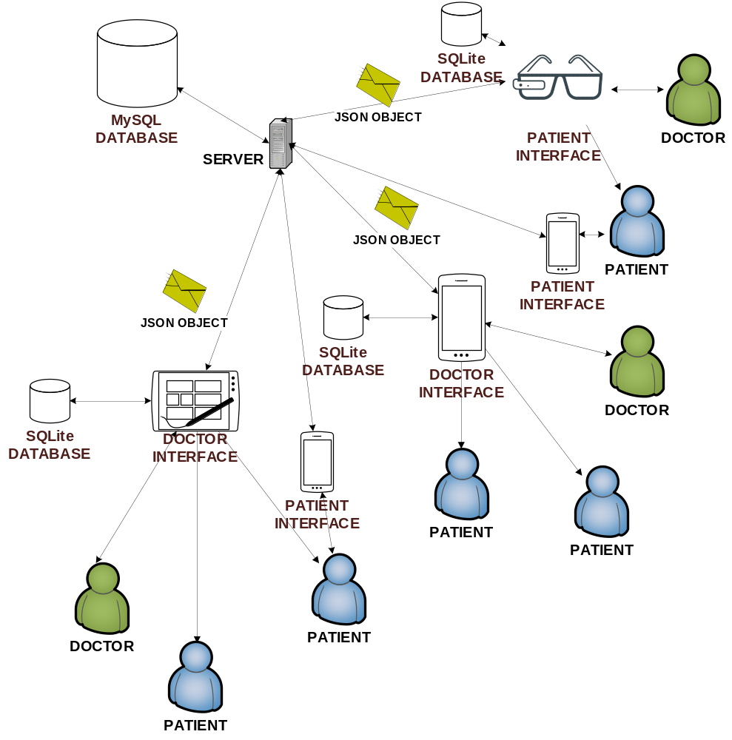
Figure 1. System Architec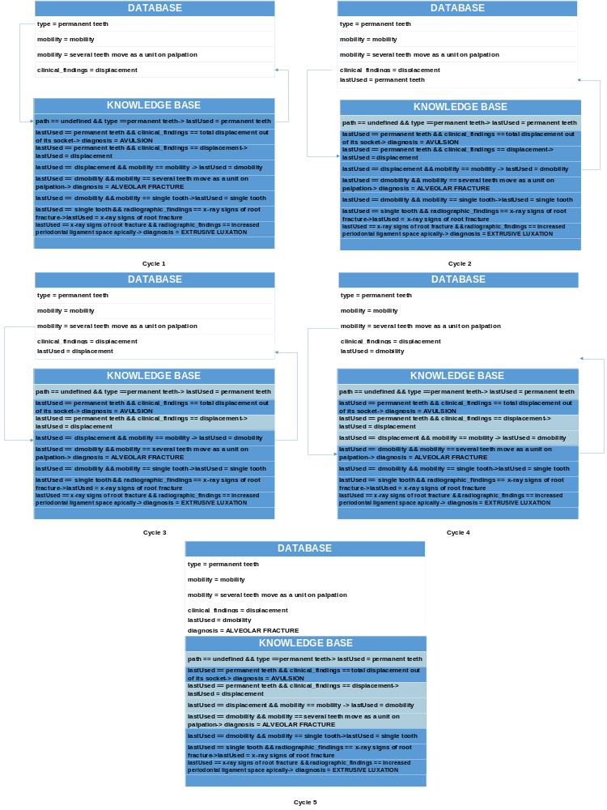
Figure 2. Forward-Chaining Method
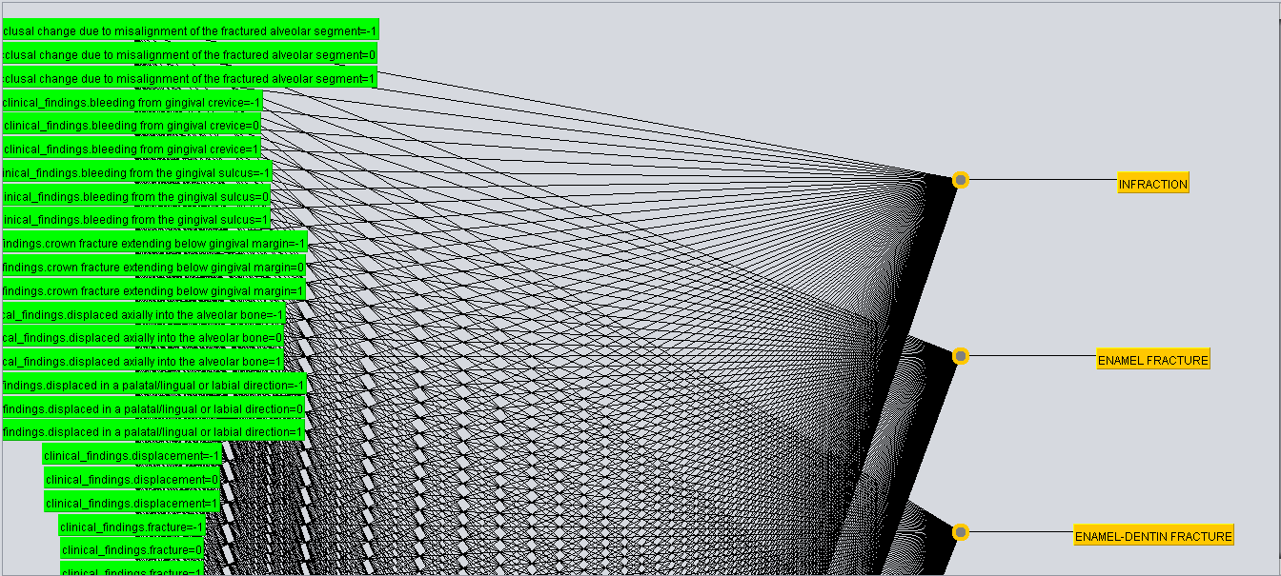
Figure 3. Architecture of KBANN 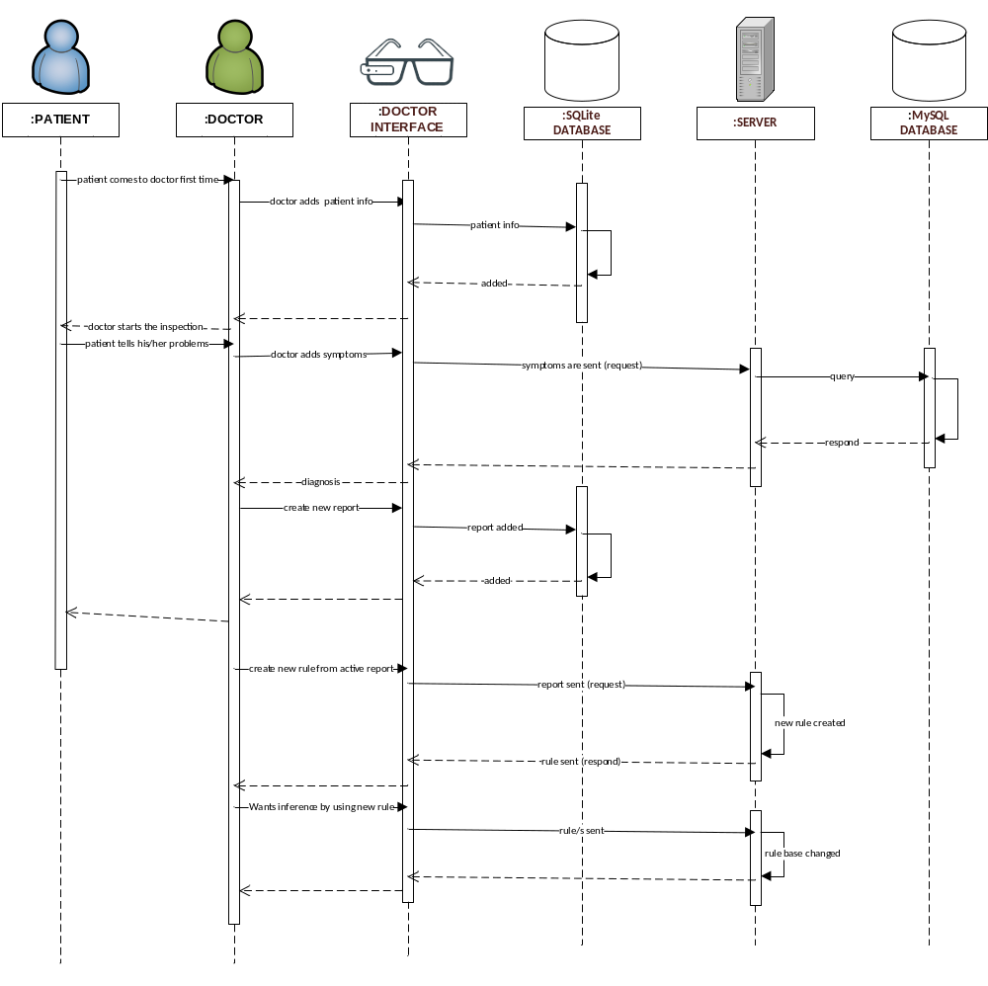
Figure 4. Creating New Rule Sample
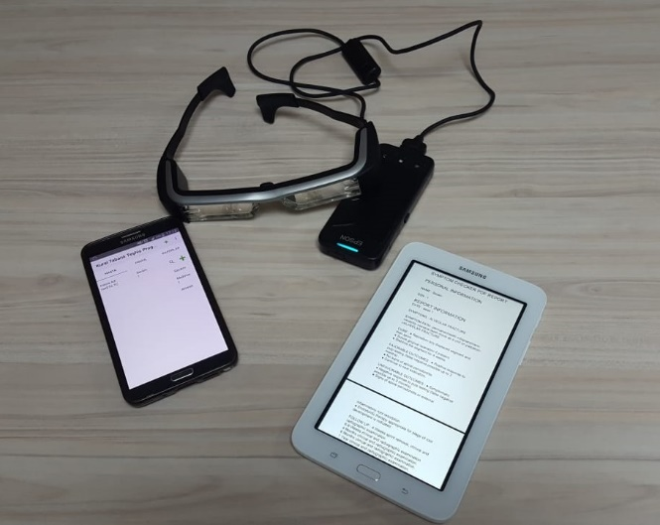
Figure 5. Used Devices

APPENDIX 2 (TABLES)
- Given:
  - An approximately correct domain theory with rules and features to used for describing examples
  - A set of examples
- Do:
  - Map the knowledge structure (domain theory) into a neural network
  - Train the KBN (knowledge-based network) using set of examples.
  - After training, the trained network can classify the future unseen examples

Table 1. The KBANN Learning Algorithm

 | MultilayerPerceptron | KStar | IBk | SMO | Simple Logistic
Total Number of Instances | 32 | 32 | 32 | 32 | 32
Correctly Classified Instances | 25 | 25 | 23 | 28 | 25
Accuracy | %78.125 | %78.125 | %71.875 | %87.5 | %78.125
RMSE | 0.1384 | 0.1603 | 0.1733 | 0.1114 | 0.2454
MAE | 0.0416 | 0.0402 | 0.0691 | 0.031 | 0.1247
Kappa | 0.7635 | 0.7635 | 0.6959 | 0.865 | 0.7635
Table 2. Performance Comparision Among Some Weka Algorithms in Cross-Validation 10 Folds Test

 | Neural Expert System Based Dental Trauma Diagnosis Application for Wearable Devices | Tooth SOS
Made for whom? | - For dentists. | - For professionals and patients.
The ability of the system making diagnosis | - If symptoms are given, the system can diagnose using by rule-based forward chaining method.  - Diagnosis is impossible without symptoms. | - The system cannot diagnose automatically.  - ‘What does Injury look like’ part can give a patient an opinion.
Registration | - Patients and dentist can register. | - Membership can be bought.
Data storage | - Patient’s personal information and medical reports are stored in a database at doctor’s device.  - Sickness information is stored in a database at the server.
Data alteration | - Data in a dentist’s device can be altered or deleted.
Information about sickness | - Symptom path, cure, favorable outcomes, unfavorable outcomes and follow-up and visualized symptom path are specified in the medical report. | - There is published guidelines.  - Images on ‘I have a tooth injury’ part may help.
Information about how dental injuries are prevented | - There is no information. | - There is ‘How to prevent dental injuries’ part.
Information about mouthguards | - There is no information. | - There is ‘Mouthguards’ part.
Find an IADT dentist | - There is no information. | - There is ’Find an IADT dentist ‘part.
Reporting | - User can create PDF report. | - There is no information.
What to do when an accident happened | - There is no information. | - What to do is specified step by step.  - In addition, there are also recommendations.
Is Internet connection necessary? | - It is not essential to add, delete, alter patient information, reports, and doctor information.  - Required for diagnosis and PDF converting. | - It is not necessary for patients.  - It is dependent on the opened page for professionals.
Multilanguage support | - English | - English  - Turkish  - Greek  - Spanish  - German  - Italian  - Hebrew  - Portuguese
Share button | - There is no share button. | - There is a share button.
Activity announcements about dental traumatology | - There is no information. | - There is a ‘Continuing Education’ part.
Dependency on device | - User depends on a device. If device is changed, user has to create the database again. | - There is no dependency.
Table 3. Comparision With Tooth SOS Application

